RFID system operation factors

# 1: Mounting location

**RFID (Radio Frequency Identification)** RFID systems are used in many places including manufacturing, contactless payment systems, keyless entry, toll collection, and baggage handling. It’s a touch-free way to identify items. RFID systems include a tag and a reader. The reader sends out a radio signal that causes the tag to send a reply. That reply can be read by a computer attached to the reader.

Being mounted near metal is a problem since when operating, radio signals get reflected by the metal and this reduces the read range. If a reader is located on or near metal, special tags are need - called “on-metal” or “metal” tags. All tags have “Data Carrier Distance to Metal” and “Data Carrier Clear Zone” dimensions to maximize read range.

# 2. Distance between tag and reader

A RFID signal is **strongest** near the antenna and gets *weaker* as the distance increases. Manufacturers indicate a maximum distance and an offset. The maximum distance is the read/write range of the tag, whereas offset is basically a tolerance for that value.

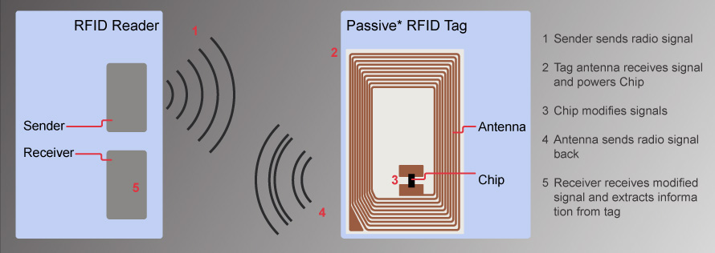

[This Photo](https://electronics.stackexchange.com/questions/334419/how-does-rfid-reader-reads-a-passive-rfid-tag) by Unknown Author is licensed under [CC BY-SA](https://creativecommons.org/licenses/by-sa/3.0/) (Creative Commons), accessed 7/5/2019

# 3. Transmission time

There are two types of transmission: static (stationary) and dynamic (moving). Both static and dynamic transmission times indicate the time required to transmit data between the reader and the tag. Dynamic tags must stay in the read range for the entirety of the time.

# 4. Environmental conditions

Components can be made to withstand extreme temperatures, pressures, and humidity levels. It is best to avoid noisy motors, variable frequency drives, and other RFID readers. These all can create electrical noise that messes up – or just delays – the read/write process.